3 Days 2 Nights Kinabalu 5-star Getaway Package

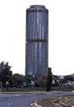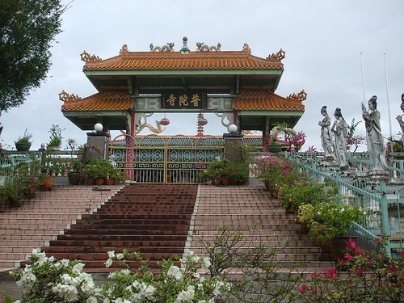

Package Rate per pax (RM)  Room based on R.O.H. |  | 2 - 3 pax  ~ seat-in-coach ~ | 4 – 5 pax  ~ seat-in-coach ~
 |  | Twin/Triple | Twin/Triple
5* Hyatt Regency (Superior Room)  5* Le Meridien Hotel (Superior Room) |  | 819.00 | 699.00
5* Pacific Sutera (Deluxe Golf View) |  | 869.00 | 759.00
Shangri-La’s Tanjung Aru Resort  ( Kinabalu Mountain View ) |  | 1009.00 | 899.00
~ Child with extra bed @ 100% of adult rate.
~ Child without bed @ 80% of adult rate
PACKAGE INCLUDES : | ~ 2 Nights accommodation at City Hotel of your choice.  ~ 2 Breakfast, 1 Lunch, 1 Dinner.
PACKAGE EXCLUDED : | ~ Airfare & Airport Taxes.  ~ Service Fee/Tipping for Tour Guide & Driver of RM 10.00 per pax per day.  ~ Travel Insurance & Personal MISC Expenses.  ~ Peak Season Surcharge .

Itinerary :
Day 01 ARRIVAL KOTA KINABALU (L,D)
Meet arrival, proceed to City Tour : Tun Mustapha Building, Chinese Buddhist Temple, State Mosque. After tour, transfer to Hotel for check in.
Seafood Dinner with a colorful cultural show will be served at local restaurant

Day 02 KOTA KINABALU (B)
Hotel breakfast, free at own leisure

Day 03 KOTA KINABALU – DEPARTURE (B)
Hotel breakfast, free at own leisure until transfer to Airport for departure

Notes :
- Each room must be at least 2 adults paying full fare then only follow by child fare.
- The above rate are subject to acceptance of resort’s term & conditions of contracts.
- The Hotel reserves all rights to revise the contracted rates without prior notice.
- Validity : Until March 2012.
- All rate quoted is base on RINGGIT MALAYSIA

